Computer Vision Homework 9

Name: 黃新予

Student ID: f08922136

**All of the operator implementation follows the introduction on the PDF.**

1. **padding**
2. **create np array for different algorithm, e.g. r0, r1, r2, k0, k1, k2…etc**
3. **use different filter to determined whether the value is greater than threshold or not.**
4. **Put corresponding pixel value on new image.**
5. **Result:**

(a) Robert's Operator: 35

|  |  |  |
| --- | --- | --- |
|  |  |  |
| 原圖 | Threshold =40 | Threshold = 35 |

(b) Prewitt's Edge Detector: 30

|  |  |  |
| --- | --- | --- |
|  |  |  |
| 原圖 | Threshold =24 | Threshold = 30 |

(c) Sobel's Edge Detector: 50

|  |  |  |
| --- | --- | --- |
|  |  |  |
| 原圖 | Threshold =38 | Threshold = 50 |

(d) Frei and Chen's Gradient Operator: 40

|  |  |  |
| --- | --- | --- |
|  |  |  |
| 原圖 | Threshold =30 | Threshold = 40 |

(e) Kirsch's Compass Operator: 150

|  |  |  |
| --- | --- | --- |
|  |  |  |
| 原圖 | Threshold =135 | Threshold = 150 |

(f) Robinson's Compass Operator: 60

|  |  |  |
| --- | --- | --- |
|  |  |  |
| 原圖 | Threshold =43 | Threshold = 60 |

(g) Nevatia-Babu 5x5 Operator: 13000

|  |  |  |
| --- | --- | --- |
|  |  |  |
| 原圖 | Threshold =12500 | Threshold = 13000 |

**Padding implementation**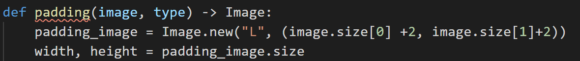for Robert operator

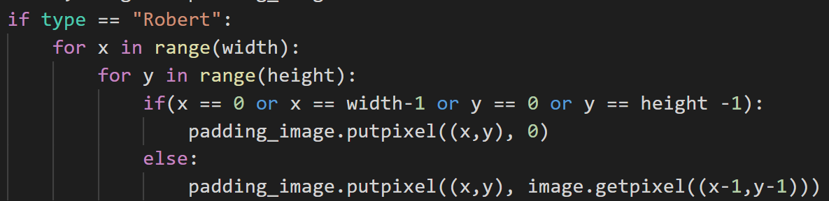

For the other

